

# 

### Semester Two Examination, 2018

### Question/Answer booklet

# MATHEMATICS

If required by your examination administrator, please place your student identification label in this box

**SPECIALIST**

**UNITS 1 AND 2**

## Section One:

## Calculator-free

|  |  |  |  |  |  |  |  |  |  |  |
| --- | --- | --- | --- | --- | --- | --- | --- | --- | --- | --- |
| Student number: In figures |  |  |  |  |  |  |  |  |  |  |

In words

Your name

## Time allowed for this section

Reading time before commencing work: five minutes

Working time: fifty minutes

## Materials required/recommended for this section

***To be provided by the supervisor***

This Question/Answer booklet

Formula sheet

***To be provided by the candidate***

Standard items: pens (blue/black preferred), pencils (including coloured), sharpener,  
correction fluid/tape, eraser, ruler, highlighters

Special items: nil

## Important note to candidates

No other items may be taken into the examination room. It is **your** responsibility to ensure that you do not have any unauthorised material. If you have any unauthorised material with you, hand it to the supervisor **before** reading any further.

## Structure of this paper

|  |  |  |  |  |  |
| --- | --- | --- | --- | --- | --- |
| Section | Number of questions available | Number of questions to be answered | Working  time (minutes) | Marks available | Percentage of examination |
| Section One:  Calculator-free | 8 | 8 | 50 | 52 | 35 |
| Section Two:  Calculator-assumed | 13 | 13 | 100 | 98 | 65 |
|  | | |  | **Total** | 100 |

|  |  |  |
| --- | --- | --- |
| Markers use only | | |
| Question | Maximum | Mark |
| 1 | 7 |  |
| 2 | 4 |  |
| 3 | 6 |  |
| 4 | 8 |  |
| 5 | 6 |  |
| 6 | 8 |  |
| 7 | 5 |  |
| 8 | 8 |  |
| S1 Total | 52 |  |
| S1 Wt (×0.6731) | 35% |  |
| S2 Wt | 65% |  |
| Total | 100% |  |

## Instructions to candidates

1. The rules for the conduct of examinations are detailed in the school handbook. Sitting this examination implies that you agree to abide by these rules.

2. Write your answers in this Question/Answer booklet.

3. You must be careful to confine your response to the specific question asked and to follow any instructions that are specified to a particular question.

4. Supplementary pages for the use of planning/continuing your answer to a question  
have been provided at the end of this Question/Answer booklet. If you use these pages to continue an answer, indicate at the original answer where the answer is continued, i.e. give the page number.

5. Show all your working clearly. Your working should be in sufficient detail to allow your answers to be checked readily and for marks to be awarded for reasoning. Incorrect answers given without supporting reasoning cannot be allocated any marks. For any question or part question worth more than two marks, valid working or justification is required to receive full marks. If you repeat any question, ensure that you cancel the answer you do not wish to have marked.

6. It is recommended that you do not use pencil, except in diagrams.

7. The Formula sheet is not to be handed in with your Question/Answer booklet.

Section One: Calculator-free 35% (52 Marks)

This section has**eight (****8)** questions. Answer **all** questions. Write your answers in the spaces provided.

Working time: 50 minutes.

Question 1 (7 marks)

Let $A=\left[\begin{matrix}2 & -1 \\ -3 & 0\end{matrix}\right]$ and $B=\left[\begin{matrix}5 & 4 \\ 7 & 6\end{matrix}\right]$.

Determine

(a) $AA^{-1}$. (1 mark)

(b) $2A+B$. (2 marks)

(c) $AB$. (2 marks)

(d) $B^{-1}$. (2 marks)

Question 2 (4 marks)

$z_{1}$ and $z_{2}$ are the complex solutions to the equation $z^{2}-2z+10=0$.

The location of $z_{1}$ is shown in the complex plane below.

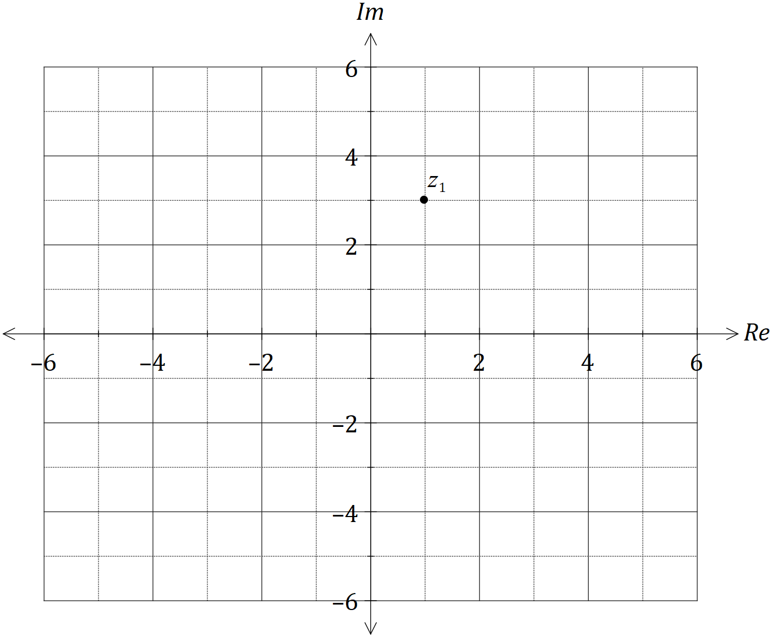

Add, with a label, the following complex numbers to the complex plane above.

(a) $z_{2}$. (1 mark)

(b) $u=z_{1}+z_{2}$. (1 mark)

(c) $v=iz_{1}$. (1 mark)

(d) $w=\overline{u+v}$. (1 mark)

Question 3 (6 marks)

(a) Draw a neat diagram to illustrate the angle in the alternate segment theorem. (2 marks)

(b) Consider the statement 'if a pentagon is regular, then it has sides of equal length'.

(i) Write the inverse of the statement. (1 mark)

(ii) Write the contrapositive of the statement. (1 mark)

(iii) Write the converse of the statement and neatly sketch a counter-example to show that the converse is not true. (2 marks)

Question 4 (8 marks)

(a) On the axes below, sketch the graphs of $y=\tan\left(\begin{matrix}x \\ \overline{2}\end{matrix}\right)$ and $y=\cot\left(\begin{matrix}x \\ \overline{2}\end{matrix}\right)$, where $0≤x≤360°$, labelling all asymptotes. Note that $\tan{76°}≈4$. (5 marks)

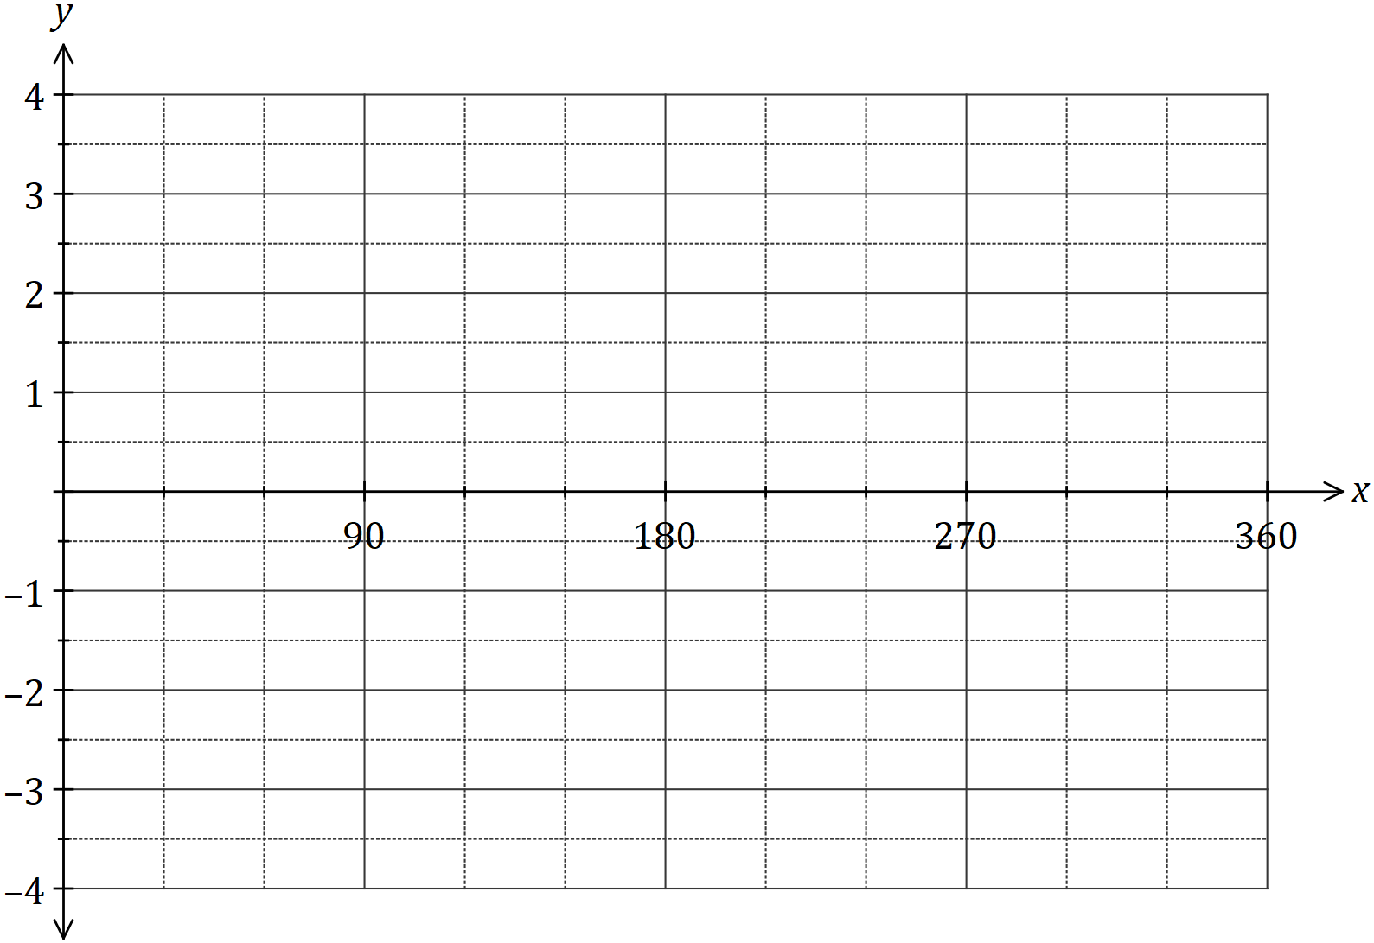

(b) Solve the equation $\sec^{2}{(x)}=3\tan^{2}{(x)}-1$ over the interval $0≤x≤360°$. (3 marks)

Question 5 (6 marks)

The position vectors of points $P$ and $Q$ are $p=\left[\begin{matrix}3 \\ 1\end{matrix}\right]$ and $q=\left[\begin{matrix}1 \\ -1\end{matrix}\right]$ respectively.

(a) Determine the magnitude of the displacement vector $\vec{PQ}$. (2 marks)

(b) Determine the values of $λ$ so that $\left|p-λq\right|=4$. (4 marks)

Question 6 (8 marks)

Let $f\left(x\right)=2\sin{x}+2\cos{x}$.

(a) Express $f(x)$ in the form $r\sin\left(x+α\right)$ where $0<α<\frac{π}{2}$. (4 marks)

(b) Sketch the graph of $y=f(x)$. (4 marks)

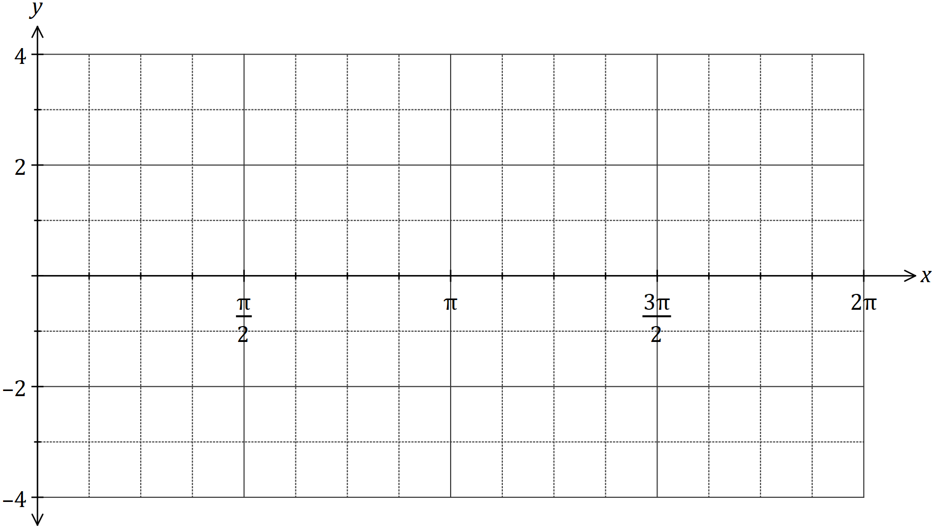

Question 7 (5 marks)

Let $OAPB$ be a parallelogram where $\vec{OA}=a$ and $\vec{OB}=b$.

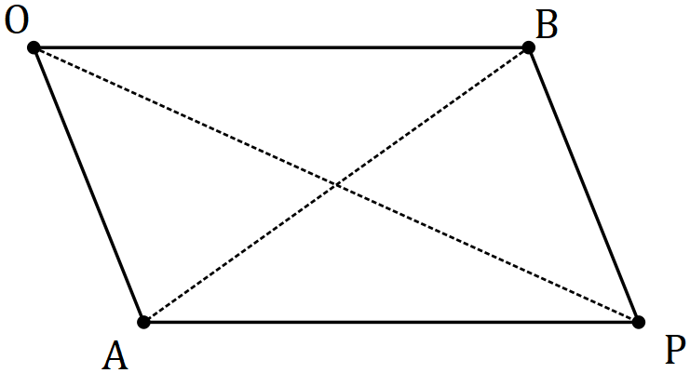

Use a vector method to prove that the sum of the squares of the lengths of the diagonals of a parallelogram is equal to the sum of the squares of the lengths of the sides.

Question 8 (8 marks)

(a) Determine all complex solutions to the equation $z^{2}-2z+5=0$. (3 marks)

(b) Determine the values of the **positive** real constants $p$ and $q$ so that $p-2i$ is a solution to the equation $2z^{2}-qz+26=0$. (5 marks)

Supplementary page

Question number: _________

© 2018 WA Exam Papers. Carmel School has a non-exclusive licence to copy and communicate this document for non-commercial, educational use within the school. No other copying, communication or use is permitted without the express written permission of WA Exam Papers. SN014-121-1.